Task-1: Key differences in SDLC & STLC and process.

#### **Key Difference between SDLC and STLC :**

* SDLC defines all the standard phases which are involved during the software development process, whereas the STLC process defines various activities to improve the quality of the product.
* SDLC is a Development Life Cycle, whereas STLC is a Testing Life Cycle.
* In SDLC, the development team creates the high and low-level design plans, while In STLC, the test analyst creates the System, Integration Test Plan
* In SDLC, real code is developed, and actual work takes place as per the design documents, whereas in STLC testing team prepares the test environment and executes test cases.
* The SDLC life cycle helps a team complete the software’s successful development, while the STLC phases only cover software testing.

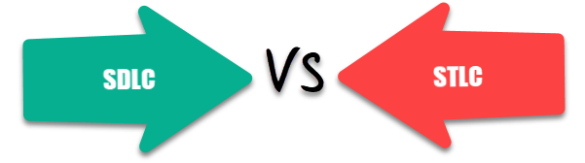SDLC vs STLC

# SDLC VS. STLC

In this section, we are going to discuss the difference between the ****SDLC and STLC**** as we understood that both are an integral part of Software testing.

But before we see the difference between ****SDLC and STLC****, first, we will understand the ****SDLC and STLC**** in brief.

## **What SDLC?**

Software Development Life Cycle (SDLC) defines all the standard phases which are involved during the software development process. [SDLC life cycle](https://www.guru99.com/software-development-life-cycle-tutorial.html) is a process of developing software through a phased manner in the following order

1. Requirements Gathering
2. Design the software
3. Build the Software
4. Test
5. Deployment
6. Maintenance****.****

Each stage has definite entry and exit criteria along with deliverables.

## **Difference between SDLC and STLC:**

In the below table, we have listed some of the important difference between the ****Software Development Life Cycle**** and ****Software Testing Life Cycle****:

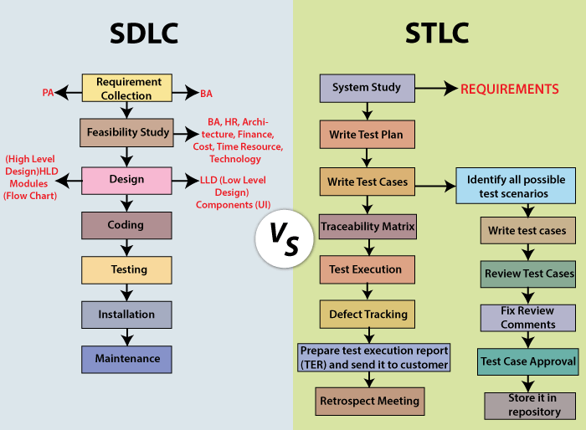

## **What is STLC?**

Software Testing Life Cycle (STLC) is the testing process that is executed in a well-planned manner. In the STLC process, various activities are carried out to improve the quality of the product. However, [STLC phases](https://www.guru99.com/software-testing-life-cycle.html) only deal with testing and detecting errors but not development itself.

Different companies define different phases in STLC. However, generic Software Test Life Cycle has the following stages.

1. Requirement Analysis
2. Test Planning
3. Test Development
4. Test Environment Setup
5. Test Execution & Closure

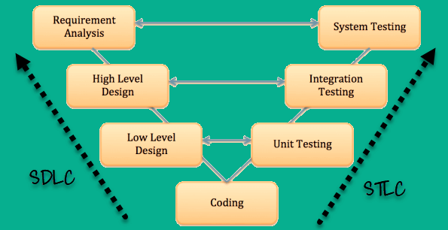

## **Why Use SDLC?**

Here, are some prime reasons for using SDLC method:

* It aims to produce a high-quality software system which helps you to meet the customer expectations
* A formal review is created after completion of every stage that provides optimum management control.
* SDLC helps you to create considerable system documentation
* It produces many intermediate products which can be reviewed to verify whether they can meet the user’s needs and are according to the stated requirement.
* SDLC helps you to ensures that system requirements can be traced back to stated business requirements
* Every phase has a specific deliverable, entry and exit criteria
* Development stages go one by one which is an ideal option for the small or mid-sized projects where requirements are clear.

## **Why STLC?**

Here, are Important reasons for using STLC method:

* STLC helps make the testing process more sophisticated, consistent and effective
* You can include milestones and deliverables for each step of the project
* Easy to understand and implement even if the model is expanded to various levels
* Time constraints are strongly built in project formulation
* Each module of the project is tested before the beginning of the another module
* The requirement of the specific project is measured against the actual result

## **Difference Between SDLC and STLC :**

Following table shows key difference between SDLC and STLC

| **Parameter** | **SDLC** | **STLC** |
| --- | --- | --- |
| Origin | Development Life Cycle | Testing Life Cycle |
| Objective | The main object of SDLC life cycle is to complete successful development of the software including testing and other phases. | The only objective of the STLC phase is testing. |
| Requirement Gathering | In SDLC the business analyst gathers the requirements and create Development Plan | In STLC, the QA team analyze requirement documents like functional and non-functional documents and create System Test Plan |
| High & Low-Level Design | In SDLC, the development team creates the high and low-level design plans | In STLC, the test analyst creates the Integration Test Plan |
| Coding | The real code is developed, and actual work takes place as per the design documents. | The testing team prepares the test environment and executes them |
| Maintenance | SDLC phase also includes post-deployment supports and updates. | Testers, execute regression suits, usually automation scripts to check maintenance code deployed. |

## **Features of SDLC**

* The model structure & functions are well documented, and the tested result is readily available.
* The project can be completed step by step before another project begun. Project units are distinct and easily identifiable.
* Risk management is integral to the model and is handled efficiently.
* The project can be designed so that the pieces should be sourced.

## **Features of STLC**

* STLC analyze system requirements collected from clients and stakeholders,
* Helps you to create traceability Matrix.
* Identify the testing technique and testing types.
* Prioritize the feature which should be primarily targeted on the test.
* You can Analyze the Automation feasibility with STLC.
* Identify the information about the testing environment where the actual test should be executed.